Apache Tomcat

Intro
The Apache Tomcat server is an open source, Java-based web application container that was created to run servlet and JavaServer Pages (JSP) web applications.

It was created under the Apache-Jakarta subproject; however, due to its popularity, it is now hosted as a separate Apache project, where it is supported and enhanced by a group of volunteers from the open source Java community.

Apache Tomcat is very stable and has all of the features of a commercial web application container. Tomcat also provides additional functionality that makes it a great choice of developing a complete web application solution:
- Tomcat Manager application
- Specialized Realm Implementation
- Tomcat valves

Tomcat Architecture

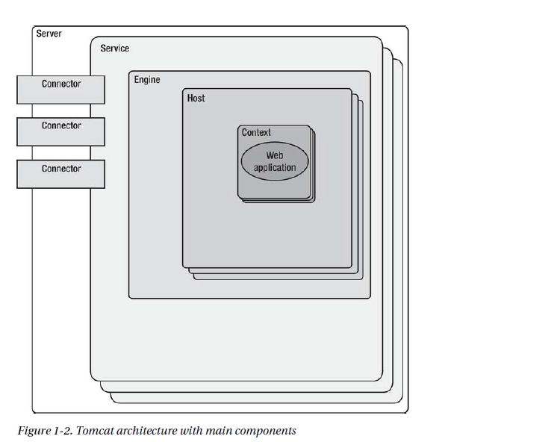
Context=SevletContext
rappresenta una web app
The instance can be broken down into a set of containers including a server, a service, a connector, an engine, a host, and a context. By default, each of these containers is configured using the server.xml file.

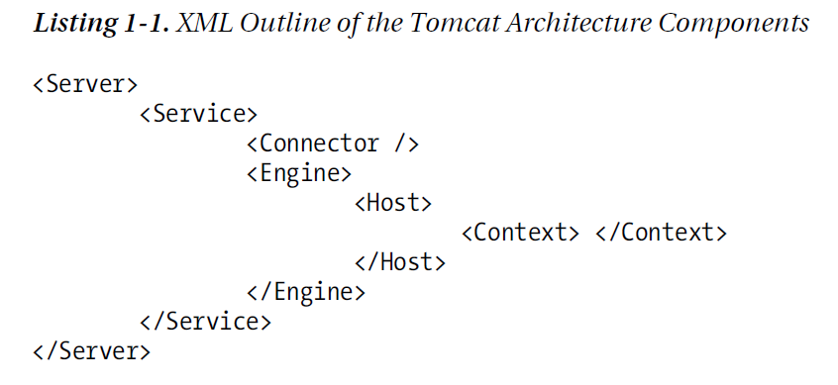
The Server
A Tomcat instance, or server, is the top-level component in Tomcat's container hierarchy. Only one Tomcat instance can live in a single Java Virtual Machine.

The Service
<Service> element holds a collection of one or more <Connector> elements that share a single <Engine> element.

The Connector
<Connector> element defines the class that does the actual handling requests and responses to and from a calling client application.
The Engine (Catalina servlet engine)
Catalina is the actual Java servlet container implementation as specified in Java Servlet API.
Each defined <Service> can have only one <Engine> element, and this single <Engine> component handles all requests received by all of the defined <Connector> components defined by a parent service.

The Host
The <Host> element defines the virtual hosts that are contained in each instance of a Catalina <Engine>. Each <Host> can be parent to one or more web applications, with each being represented by a <Context> component.

The Context (ServletContext)
The <Context> elements is the most commonly used container in a Tomcat instace. Each <Context> element represents an individual web application that is running within a defined <Host>. There is no limit to the number of contexts that can be defined within a <Host>.

The Web Application
Each web application can contain multiple servlet.

WebApplication
The concept of a web application was introduced with the release of the Java servlet specification 2.2. According to this specification, “a web application is a collection of servlets, html pages, classes, and other resources that can be bundled and run on multiple containers from multiple vendors”.

One of the main characteristics of a web application is its relationship to the ServletContext. Each web application has one and only one ServletContext. This relationship is controlled by the servlet container and guarantees that no two web application will clash when accessing objects in the ServletContext.

At the heart of all web applications is a deployment descriptor that is an XML file named web.xml. The deployment descriptor is located in the WEB-INF/ directory within the main application directory. It contains configuration information for the entire web application. The information that is contained in the deployment descriptor includeds the following elements:
- Servlet definitions
- Servlet initialization parameters
- Session configuration parameters
- Servlet/JSP mappings
- MIME type mappings
- Security configuration parameters
- Welcome file list
- List of error pages
- Resource and environment variable definitions

Tomcat Directory Structure

Directory | Contents
/bin | Contains the startup and shutdown scripts for both Windows and Linux. Jar files with classes required for tomcat to start are also stored here.
/conf | Contains the main configuration files for Tomcat. The two most important are server.xml and the global web.xml
/lib | Contains the Tomcat Java Archive (jar) files, shared across all Tomcat components. All web application deployed to Tomcat can access the libraries stored here. This includes the Servlet API and JSP API libraries.
/logs | Contains Tomcat's log files.
/temp | Temporary file system storage.
/webapps | The directory where all web applications are deployed, and where you place your WAR file when it is ready for deployment.
/work | Tomcat's working directory where Tomcat places all servlets that are generated from JSPs. If you want to see exactly how a particular JSP is interpreted, look in this directory.

The option -security is used to protect Tomcat expecially from third party web application (for more details see Apache Tomcat 7 pag. 35).

Manager Web Application
Prior to Tomcat version 7, there was one user role required to access it, which was simply called “manager”. From version 7, Tomcat introduced four different roles for accessing Manager web application:
- manager-gui: Allows access to HTML interface and status pages
- manager-script: Allows access to the text-based scripting engine and status pages
- manager-jmx: Allows access via JMX proxy and status pages
- manager-status: Allows access to status pages only

Tomcat's users' usernames, passwords, and roles are stored in file CATALINA_HOME/conf/tomcat-users.xml
Example:

<user username=”managerGui” password=”abc123” roles=”manager-gui” />

Configuration (Chapter 7 [2007] Tomcat def guide)

